Deep Learning-Based Image Classification for

Kidney Tumor Detection Using ResNet-50 and

MobileNet

Archana. M

*Research Scholar, Dept of AIML*

*Saveetha School of Engineering, Saveetha Institute of*

*Medical and Technical Sciences (SIMATS), Saveetha*

*University, Chennai, India*

Email id: archanakrishna725@gmail.com

ORCID ID: 0009-0005-2125-4661

Aswathy R H

*Professor, Department of CSE*

*Saveetha School of Engineering, Saveetha Institute of*

*Medical and Technical Sciences (SIMATS), Saveetha*

*University, Chennai, India*

Email id: rhaswathy@gmail.com

Abstract:

**Kidney tumors are a crucial and life-threatening illness that necessitates precise and prompt detection in order to provide effective treatment and increase survival rates. In this paper, we look into the use of deep learning algorithms for automated brain tumor classification from MRI scans, specifically comparing the ResNet-50 and MobileNet architectures. The method entails preprocessing MRI images, feature extraction, and classification using these two cutting-edge deep learning models. The results show a considerable difference in performance between the algorithms. MobileNet produced an impressive 98% accuracy, significantly exceeding ResNet-50's 78%. This demonstrates MobileNet greater capacity to distinguish between benign and malignant tumors, making it a more robust and dependable choice for automated brain tumor identification**

Keywords:

*ResNet50, MobileNet, Tumor, MRI Scans, Deep Learning*

# I. Introduction

The human body's kidneys filter toxins and waste from the blood. Tumors (cancers) are caused by aberrant cell proliferation, which has varying effects on individuals and produces a range of symptoms. Consequently, one of the most important steps in lowering the risk of further disease progression is the early diagnosis of kidney tumors (KT)[(Alzu’bi et al. 2022)](https://paperpile.com/c/LVJTOb/OxwE)This ultimately results in the preservation of the patient's life. The majority of KT disorders do not cause symptoms, while about one-third of cases are found after spreading to other locations. They are frequently discovered while individuals are receiving treatment for other illnesses. On radiography, kidney tumors can be unintentionally seen as masses, kidney cysts, or patient abdominal pain. The kidneys are probably unrelated to the symptoms.

Unfortunately, cancer is frequently the cause of solid masses and tumors that develop inside the kidneys [(Mahmud et al. 2023)](https://paperpile.com/c/LVJTOb/JhuB). The pace of illness recovery may be influenced by the early discovery of the tumor since the purpose of detecting its presence is to select the best treatment option. Computed tomography (CT) scans of the abdomen and pelvis are one of the tests required to identify the tumor. These scans are performed on patients whose characteristics are examined to establish whether the kidney has a tumor. In addition to a 3D volume depiction of the kidneys (renal cancer in blue and kidney in pink), Figure 1 depicts a case of KT, a renal mass lesion in the left kidney measuring approximately 4 cm. Since a tumor poses a life-threatening threat, numerous methods. Consequently, new techniques for kidney tumor early detection have been developed Additionally, patient data such as clinical reports and biomarkers in radiological techniques has grown in importance in the creation of prediction models, leading to better clinical outcomes [(Gharaibeh et al. 2022)](https://paperpile.com/c/LVJTOb/d4cR). Improving early diagnosis and treatment for patients with kidney tumors is one of these advanced kidney tumor imaging techniques.

# II. Related Work

A kidney tumor can be either benign or malignant, and it is defined as the growth of abnormal tissue in one or both kidneys[(Hadjiyski 2020)](https://paperpile.com/c/LVJTOb/pq7s). Kidney cells can be impacted by KT. According to medical professionals, kidney tumors start when "mutations" or changes take place in the DNA of certain kidney cells, which includes instructions for the cell to follow in order to grow and reproduce rapidly. In addition, the tumor may originate inside the kidney, and in certain instances, it may be a secondary tumor that has spread from other organs, like a lung tumor. Cells may also divide and spread to other parts of the body[(Etem and Teke 2024)](https://paperpile.com/c/LVJTOb/1oy5). KT has varying effects on people and produces a range of symptoms and indicators, such as decreased appetite.

Chow et al. conducted a statistical study on the impact of obesity and high blood pressure on the risk of developing Kidney Tumors in men. Researchers used medical data for 363,992 Swedish men who had at least one physical examination between 1971 and 1992 and were followed until death or the end of 1995. [(Chow et al. 2000)](https://paperpile.com/c/LVJTOb/IMvV) the majority of the analysis was adopted on data from the baseline test for the whole group, by cross-correlating the results with the Swedish cancer register nationally. The impact of improvements in the body mass index and blood pressure of men with cancer (RCC 759 and Renal Pelvic Cancer 136) were also measured. Poisson regression test was used to estimate relative risk, with modifications according to age, smoking status, BMI, and blood pressure. The results showed a direct correlation between obesity, high blood pressure, and an increased danger of developing Kidney Tumors. In addition, men who were former or current smokers were more likely to be affected with a kidney tumor and pelvic cancer than nonsmoking men. [(Chow et al. 2000)](https://paperpile.com/c/LVJTOb/IMvV)

Zhou et al. conducted a study about differentiating renal tumors based on deep learning. To investigate the effect of transfer learning on CT, they used 192 CT scans for patients to differentiate between benign and malignant tumors and attempted to improve the accuracy by building patient-level models. The CNN architecture used was cross-trained InceptionV3 to perform the classification task. Five image-level models were established for each of the slices. The performance evaluation of the model was performed using the receiver operating characteristic metric on five-fold cross-validation. [(“A Deep Learning-Based Radiomics Model for Differentiating Benign and Malignant Renal Tumors” 2019)](https://paperpile.com/c/LVJTOb/mdjO)

## III. Proposed Methodology

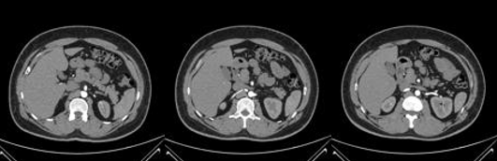

Fig 1: Sample Tumor images of Kidney

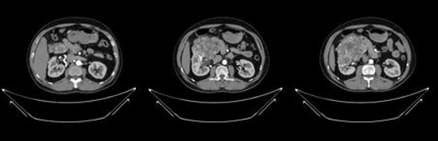

Fig 2: Sample Normal images of the Kidney

Fig 1 and Fig 2 show the sample images of the patient who is suffering from a Tumor and other side is a normal person without any complications in his Kidney system

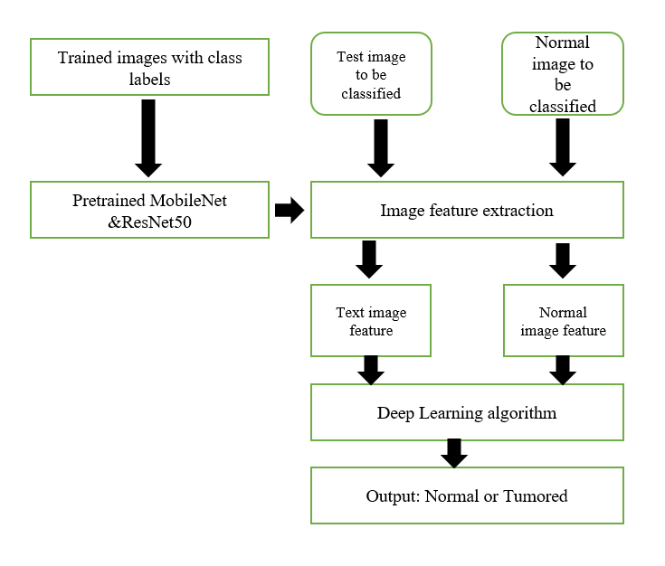

Fig 3: Proposed Flow Diagram

Fig 3 shows the flow diagram for the proposed methodology

The proposed methodology utilizes ResNet101 and MobileNet for the classification of Tumor, specifically distinguishing between normal and those affected by Tumar. The dataset is pre-processed to resize to 150x150 pixels and normalize the pixel values to increase training efficiency[(Praveen et al. 2023)](https://paperpile.com/c/LVJTOb/2eIO). It contains an equal number of photos of normal and Tumor images. Rotation, zooming, flipping both vertically and horizontally, and other data augmentation techniques are used to improve model generalization and avoid overfitting. Pretrained on ImageNet, ResNet50, and MobileNet are used as a feature extractor[(Islam et al. 2022)](https://paperpile.com/c/LVJTOb/o8yM). Transfer learning is used to refine the architecture, substituting bespoke layers for binary classification for fully connected levels. Both models ResNet50 and MobileNet both trained across 50 epochs using binary cross-entropy loss and the Adam optimizer. The model’s performance is evaluated using several metrics, such as accuracy, precision, recall, F1-score, and ROC-AUC.

In Fig 3, a deep CNN based on ResNet50 was used for classification, and transfer learning was performed using Tumor and normal images. After retraining, the last layer of the network (classification layer) was removed, and the model was regarded as an image feature extractor. [(Yu et al. 2018)](https://paperpile.com/c/LVJTOb/n4O1)

The framework of the proposed approach. Fig 3 is the process of training and Fig 4 is the process of feature extraction and classification. diagram on the far right is a visual representation of Fig 4

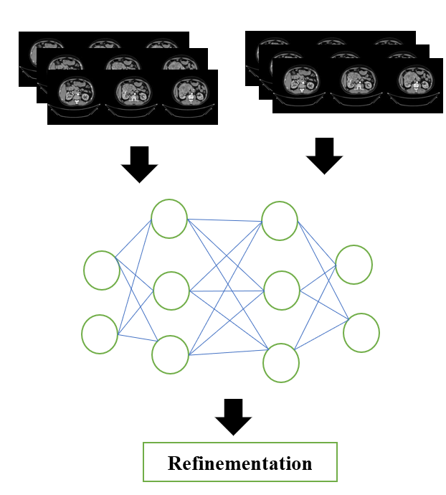

Fig 4: The feature extraction and classification

# IV. Result & Discussion

TABLE 1: Classification Report for

ResNet50

| Parameters | Precision | Recall | F1 | Support |
| --- | --- | --- | --- | --- |
| AMD | 0.85 | 0.83 | 0.84 | 41 |
| Normal | 0.83 | 0.85 | 0.84 | 40 |
| Accuracy |  |  | 0.84 | 81 |
| Macro Avg | 0.84 | 0.84 | 0.84 | 81 |
| Weighted Avg | 0.84 | 0.84 | 0.84 | 81 |

Table 1 shows the classification model's precision, recall, and F1 score were 0.83 and 0.84 for both classes, and its ac was 83%

The ResNet50 has been able to gain an accuracy of only 83% after performing over 50 epochs and it is compared to the MobileNet, and the accuracy is compared accordingly

TABLE 2: Classification Report for

MobileNet

| Parameters | Precision | Recall | F1 | Support |
| --- | --- | --- | --- | --- |
| AMD | 1.00 | 1.00 | 1.00 | 41 |
| Normal | 1.00 | 1.00 | 1.00 | 40 |
| Accuracy |  |  | 1.00 | 81 |
| Macro Avg | 1.00 | 1.00 | 1.00 | 81 |
| Weighted Avg | 1.00 | 1.00 | 1.00 | 81 |

Table 2 shows the classification models precision, recall and F1 score were 1.00 and

1.00 for both classes, and its accuracy was 100%

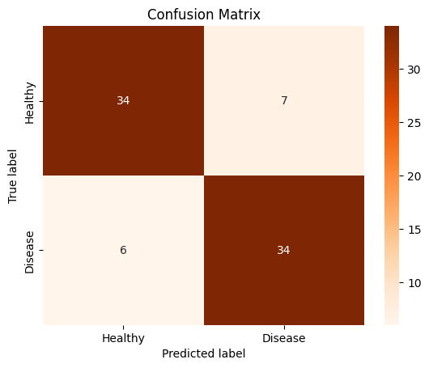

Fig 5: Confusion matrix for ResNet50

Fig 5 shows the confusion matrix for the ResNet101 model. It demonstrates good performance in differentiating between Tumar (disease) and Normal (healthy) with 34 true positive (TP) for Tumar, 34 true negative (TN) for Normal cases, 7 for false positives (FP), and 6 for false negative (FN).

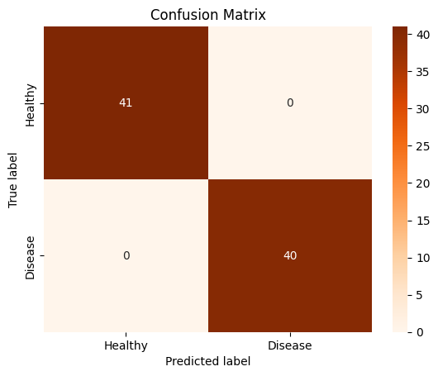

Fig 6: Confusion matrix for MobileNet

Fig 6 shows the confusion matrix for the MobileNet model. It demonstrates good performance in differentiating between Tumar (disease) and Normal (healthy) with 40 true positive (TP) for AMD, 41 true negative (TN) for Normal cases, 0 for false positives (FP), and 0 for false negative (FN).

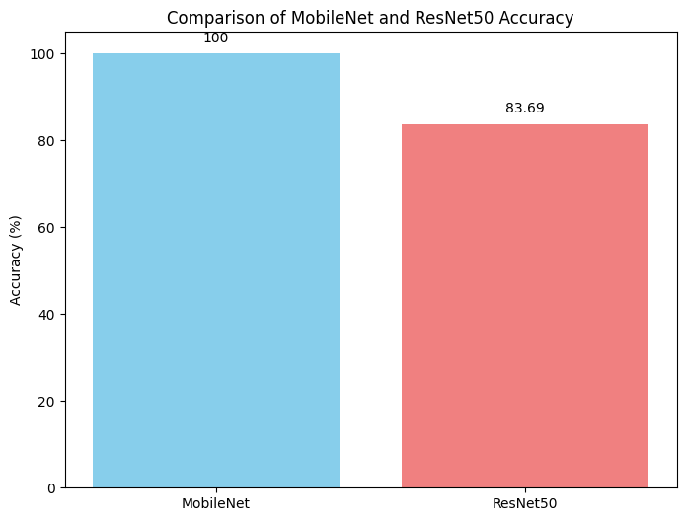

Fig 7: Accuracy comparison of ResNet50 and MobileNet

Fig 7 shows the accuracy comparison of ResNet50 and MobileNet models, with the first model achieving 83.69% of accuracy and second model achieving 100% of accuracy

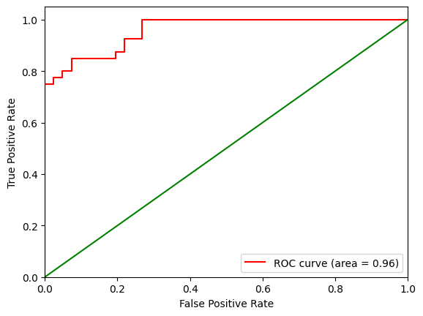

Fig 8: ROC curve for ResNet50

Fig 8 shows the ROC curve for the ResNet50 model for the tumor detection; the red line indicates that the receiver operating characteristics (ROC) are 0.96. It plots the true positive and false positive rates to demonstrate the model’s performance

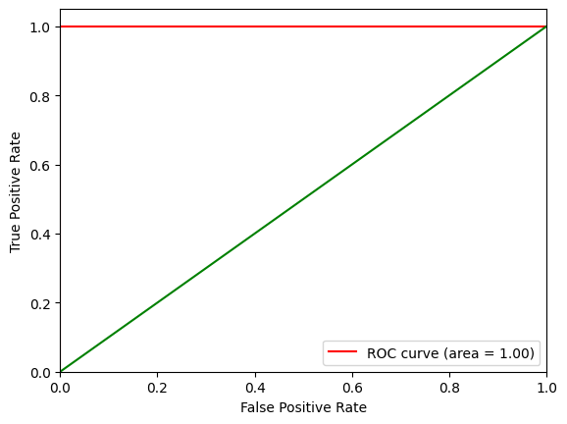

Fig 9: ROC curve for MobileNet

Fig 9 shows the ROC curve for the MobileNet model for the Tumor detection; the red line indicates that the receiver operating characteristics (ROC) are 1.00. It plots the true positive and false positive rates to demonstrate the model’s performance

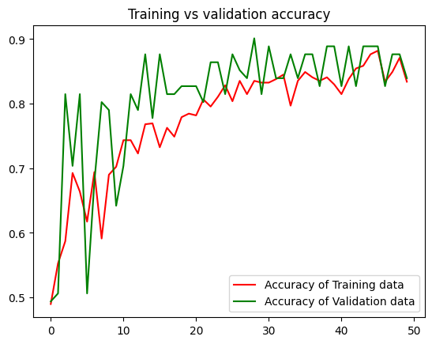

Fig 10: Accuracy curve for ResNet50

Fig 10 shows the accuracy curve for AMD Disease Detection using ResNet50 across 50 epochs. The blue line indicates an accuracy of 83% on the validation data, while the red line shows an accuracy of 83.69 on the training data. The tight alignment of these curves indicates that the model has successfully captured the patterns in the dataset and is well-optimized. Additionally, the excellent accuracy on both training and validation sets suggests that there is no overfitting, which is advantageous for deep learning models when handling challenging tasks like illness diagnosis.

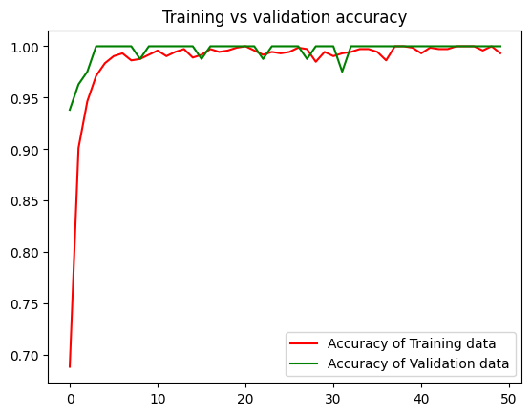

Fig 11: Accuracy curve for MobileNet

Fig 11 shows the accuracy curve for Tumar Disease Detection using MobileNet across 50 epochs. The blue line indicates an accuracy of 100% on the validation data, while the red line shows an accuracy of 100 bn the training data. The tight alignment of these curves indicates that the model has successfully captured the patterns in the dataset and is well-optimized. Additionally, the excellent accuracy on both training and validation sets suggests that there is no overfitting, which is advantageous for deep learning models when handling challenging tasks like illness diagnosis.

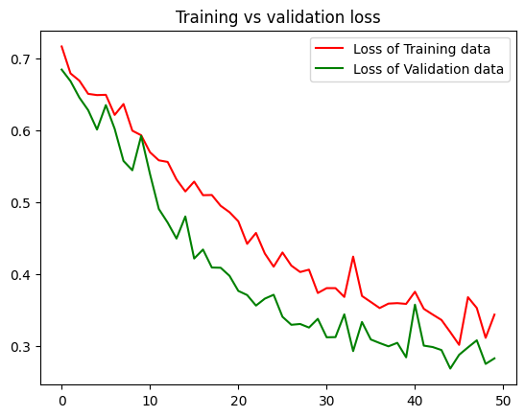

Fig 12: Loss curve for ResNet50

Fig 12 shows the loss curve for AMD detection using ResNet50 across 50 epochs. The model is effectively learning and modifying its parameters, as shown by the red line that displays validation loss, and also shows an ongoing downward trend over the epochs. Based on the concurrent decrease in training and validation loss, the model seems to be generalizing well, capturing the important data features without overfitting.

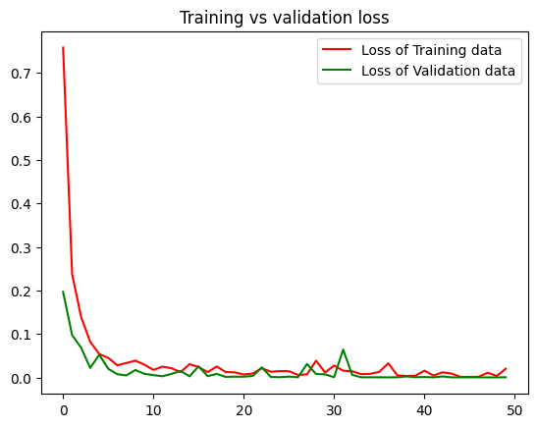

Fig 13: Loss curve for MobileNet

Fig 13 shows the loss curve for AMD detection using MobileNet across 50 epochs. The model is effectively learning and modifying its parameters, as shown by the red line that displays validation loss, and also shows an ongoing downward trend over the epochs. Based on the concurrent decrease in training and validation loss, the model seems to be generalizing well, capturing the important data features without overfitting.

# V. Conclusion

MobileNet exhibits an impressive 100% accuracy rate architecture, which effectively balances processing economy and accuracy, making it ideal for applications requiring exact classification[(Amanatulla et al. 2024)](https://paperpile.com/c/LVJTOb/Bwtx). ResNet50, which attains a lower accuracy of 83.92%, despite being designed for lightweight applications. Even an option for tumor detection.

# References

1. [“A Deep Learning-Based Radiomics Model for Differentiating Benign and Malignant Renal Tumors.” 2019. *Translational Oncology* 12 (2): 292–300.](http://paperpile.com/b/LVJTOb/mdjO)
2. [Alzu’bi, Dalia, Malak Abdullah, Ismail Hmeidi, Rami AlAzab, Maha Gharaibeh, Mwaffaq El-Heis, Khaled H. Almotairi, Agostino Forestiero, Ahmad Mohdaziz Hussein, and Laith Abualigah. 2022. “Kidney Tumor Detection and Classification Based on Deep Learning Approaches: A New Dataset in CT Scans.” *Journal of Healthcare Engineering* 2022 (October):3861161.](http://paperpile.com/b/LVJTOb/OxwE)
3. [Amanatulla, Md, G. Swathi, M. Pallavi, and K. Pavana Bindu. 2024. “MRI Scans for Deep Learning-Based Chronic Nephropathy Detection: A Comparison of CNN, MobileNet, VGG16, and ResNet-50 Models.” In *2024 5th International Conference for Emerging Technology (INCET)*, 1–6. IEEE.](http://paperpile.com/b/LVJTOb/Bwtx)
4. [Chow, Wong-Ho, Gloria Gridley, Joseph F. Fraumeni Jr, and Bengt Järvholm. 2000. “Obesity, Hypertension, and the Risk of Kidney Cancer in Men,” November. https://doi.org/](http://paperpile.com/b/LVJTOb/IMvV)[10.1056/NEJM200011023431804](http://dx.doi.org/10.1056/NEJM200011023431804)[.](http://paperpile.com/b/LVJTOb/IMvV)
5. [Etem, Taha, and Mustafa Teke. 2024. “Enhanced Deep Learning Based Decision Support System for Kidney Tumour Detection.” *BenchCouncil Transactions on Benchmarks, Standards and Evaluations* 4 (2): 100174.](http://paperpile.com/b/LVJTOb/1oy5)
6. [Gharaibeh, Maha, Dalia Alzu’bi, Malak Abdullah, Ismail Hmeidi, Mohammad Rustom Al Nasar, Laith Abualigah, and Amir H. Gandomi. 2022. “Radiology Imaging Scans for Early Diagnosis of Kidney Tumors: A Review of Data Analytics-Based Machine Learning and Deep Learning Approaches.” *Big Data and Cognitive Computing* 6 (1): 29.](http://paperpile.com/b/LVJTOb/d4cR)
7. [Hadjiyski, Nathan. 2020. “Kidney Cancer Staging: Deep Learning Neural Network Based Approach.” In *2020 International Conference on E-Health and Bioengineering (EHB)*, 1–4. IEEE.](http://paperpile.com/b/LVJTOb/pq7s)
8. [Islam, Md Nazmul, Madina Hasan, Md Kabir Hossain, Md Golam Rabiul Alam, Md Zia Uddin, and A. Soylu. 2022. “Vision Transformer and Explainable Transfer Learning Models for Auto Detection of Kidney Cyst, Stone and Tumor from CT-Radiography.” *Scientific Reports* 12 (July). https://doi.org/](http://paperpile.com/b/LVJTOb/o8yM)[10.1038/s41598-022-15634-4](http://dx.doi.org/10.1038/s41598-022-15634-4)[.](http://paperpile.com/b/LVJTOb/o8yM)
9. [Mahmud, S., T. Abbas, Adam Mushtak, Johayra Prithula, and M. E. Chowdhury. 2023. “Kidney Cancer Diagnosis and Surgery Selection by Machine Learning from CT Scans Combined with Clinical Metadata.” *Cancers* 15 (June). https://doi.org/](http://paperpile.com/b/LVJTOb/JhuB)[10.3390/cancers15123189](http://dx.doi.org/10.3390/cancers15123189)[.](http://paperpile.com/b/LVJTOb/JhuB)
10. [Praveen, S. Phani, Sampathi Rao Sidharth, Teella Komali Priya, Yaswant Sai Kavuri, Salopantula Mani Sindhura, and Swapna Donepudi. 2023. “ResNet and ResNeXt-Powered Kidney Tumor Detection: A Robust Approach on a Subset of the KAUH Dataset.” In *2023 2nd International Conference on Automation, Computing and Renewable Systems (ICACRS)*, 749–57. IEEE.](http://paperpile.com/b/LVJTOb/2eIO)
11. [Yu, Qian, Yinghuan Shi, Jinquan Sun, Yang Gao, Yakang Dai, and Jianbing Zhu. 2018. “Crossbar-Net: A Novel Convolutional Network for Kidney Tumor Segmentation in CT Images.” *arXiv [cs.CV]*. arXiv.](http://paperpile.com/b/LVJTOb/n4O1) <https://ieeexplore.ieee.org/abstract/document/8668577/>[.](http://paperpile.com/b/LVJTOb/n4O1)